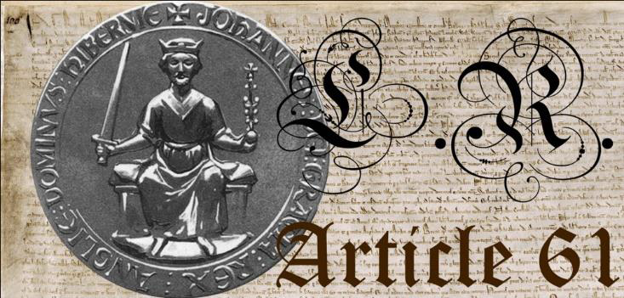

[Your Name]

[Street Address]

[Town/Suburb State Postcode]

[Town/Suburb State Postcode]

[Town/Suburb State Postcode]

To: [Recipients Full Name] doing business as;

[Name followed by Job Title]

[Street address]

[Town/Suburb State Postcode]

Date: [mailing date]

Dear [Recipients Full Name]

Please find enclosed a Notice of Conditional Acceptance requiring you to prove you have the authority to make demands on I [Your Full Name], as a living constitutional subject of the English Commonwealth Realm standing under law since the invocation of Article 61 of the 1215 Magna Carta.

Furthermore, to hold authority in a legitimate system of service to the people that we the people agreed to live under, requires an officer of the crown to swear an oath of office. Do you [Recipients full name] deny this as a fact in law?

The oath of office is a pledge each officer of the crown must take in order to have the authority granted them by we the people, as the oath is a statement of intention to make decisions on behalf of the people that fall within the confines of universal morality. Do you [Recipients full name] deny this as a fact in law?

A public servant must be able to recite and or provide their oath of office to we the people upon request. Do you [Recipients full name] deny this as a fact in law?

I [Your name] require you to send me a copy of your oath of office within 10 working days to verify that you are indeed a lawful officer of the crown making decisions on behalf of we the people that fall within the confines of the universal principles of morality.

Should you [Recipients full name] fail to adhere to the terms of the contract that binds agents and officers of the crown (public servants) by providing your oath of office in writing that proves you have taken a pledge to conduct yourself within the confines of the universal principles of morality, your silence shall be taken as evidence that you [Recipients full name] are acting immorally therefore are criminally liable for violations of the universal principles of morality along with being personally liable for crimes against we the people while masquerading as occupying public office. Do you [Recipients full name] deny this as a fact in law?

Please be advised that the 1571 Treason Act was assented to by a constitutional monarch, meaning that it is still in effect across the entire British Commonwealth Realm of which Australia is a part.

See attached Notice.

Signed: