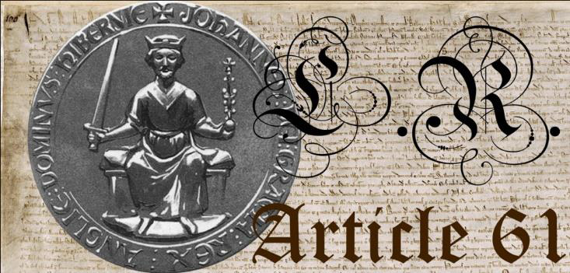

[Your Name]

[Street Address]

[Town/Suburb State Postcode]

[Town/Suburb State Postcode]

[Town/Suburb State Postcode]

To: [Recipients Full Name] doing business as;

[Name followed by Job Title]

[Street address]

[Town/Suburb State Postcode]

Date: [mailing date]

Dear [Recipients Full Name]

Please find enclosed a Notice of Conditional Acceptance, requiring you to prove you have the authority to make demands upon me, [Your Full Name], a living constitutional subject of the English Commonwealth Realm, standing under the law that governs government, since the invocation of Article 61 of Magna Carta 1215.

Magna Carta 1215 is a binding agreement that holds all public servants within the entire Commonwealth accountable to universal moral principles to ensure the competent performance of their sworn duty to support the well-being of the people. Furthermore, Magna Carta 1215 establishes the people as the supreme authority over their administrative system of service, commonly known as government.

In their daily lives, most people agree on the non-aggression principle, recognising that it is immoral and criminal to engage in theft, violence, and deception. In addition to proving the existence of a legitimate government, you, [Recipient's Full Name], as an employee of a purported man-made institution, created to equitably serve the needs of the people, would benefit from considering the implications of enforcing immoral orders that originate from the legislative branch of public servants. The moment legislation is used to grant immunity from private prosecution, while simultaneously using legislation as authority to forcibly dominate and control the people, is the moment government becomes criminal.

You would be well advised to conduct your own independent investigations into the proper establishment of the Democratic English Common Law Constitution, as it is binding on all commonwealth nations, and remains sealed in perpetuity to this day.

I urge you to carefully consider the implications for you in a court of law and not to confuse it with a court that operates under the current (il)legal system. A court of law is empaneled by a jury of equals with the independence to judge the justice of legislation along with the power to privately prosecute all people enforcing legislation that violates inviolable individual rights.

Please be advised that the 1571 Treason Act was assented to by a constitutional monarch, meaning that it is still in effect across the entire English Commonwealth Realm, of which Australia is a part.

See attached Notice.

Signed