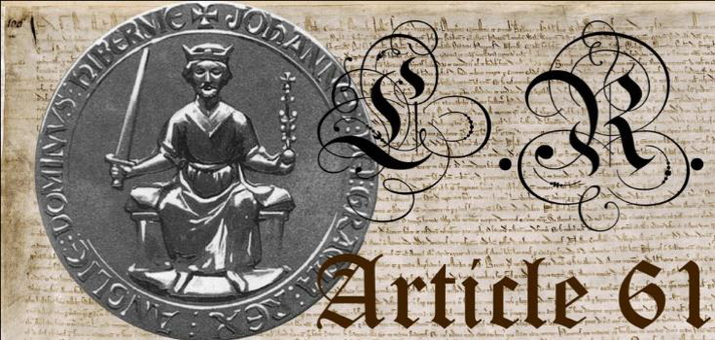

To: Lord Craigmyle

Scottas House

Knoydart

Invernesshire, PH41 4PL

Scotland

From: [Your full name here]

#### [Address]

#### [Town/Suburb State Postcode]

*Sent by recorded post*

[Date]

**Oath of Allegiance**

I, in full knowledge of treason being committed in Parliament, by delivering the Sovereign Peoples of this Common Law land into the hands of foreign powers, in understanding of some wrongs done by the present holder of the office of Sovereign, from whom I now transfer my allegiance according to the law of this land, I do so willingly, and wholeheartedly enter into lawful dissent and, I solemnly swear upon my Oath to obey the direction of the Lords of the Barons' committee whom invoked Article 61 of the 1215 Magna Carta on the 23rd March 2001 in accordance with the royal command to do so, as long as said barons act strictly according to Constitutional Law at all times without deviation, until such times as redress of these present wrongs has been achieved.

Sworn and subscribed on the .

Signed

Witnessed by:

|  |  |  |  |
| --- | --- | --- | --- |
|  | Print name | Signature | Date |
| 1 |  |  |  |
| 2 |  |  |  |
| 3 |  |  |  |