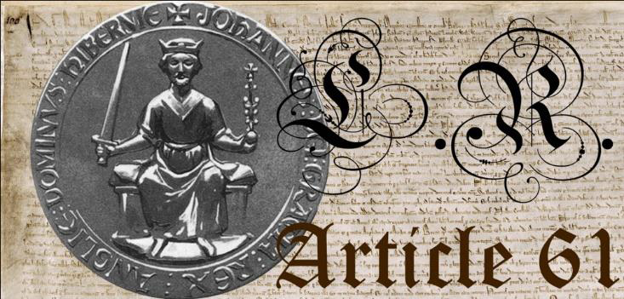

[Your Name]  
[Street Address]  
[Town/Suburb State Postcode]

To: [Recipients Name] doing business as;

[Job Title] [Recipients Name]

of [Business/gov dept]

[Street Address]

[Suburb/Town State Postcode]

Date Notice Served: [Mailing date]

*Sent by recorded post.*

Dear [Recipients Full Name],

I kindly thank you for your very seditious sworn testimony dated [insert date], ignoring my standing under the highest law ever written which breaks all assumed and presumed fraudulently created contracts that you [Recipients Full Name] claim as justification for your authority to make demand on I [Your Full Name].

Sedition at Common Law means overt conduct such as writing, speech and organisation that is deemed by the legal authority (legal authority can only exist if there is a lawful head of state in office. The Office of Sovereign was vacated in March 2001) as tending toward insurrection against the established order. Sedition includes the subversion of a constitution and incitement of discontent (or resistance) to lawful authority.

I would like to remind you that the Penalty for Sedition at Common Law is a Full Asset Stripping and Life in Prison.

My Notices are meant to Inform and Educate and compel those sworn to protect the people’s sovereignty to uphold their Oaths of Office. I realise that you will not recognise my LAWFUL Notices as you are operating as a Foreign Corporation and have no Lawful Standing or Authority since the Invocation of Article 61 according to Constitutional Royal Protocol on March 23rd, 2001. My LAWFUL Notices CLEARLY State WITHOUT Malice, Vexation, or Ill Will.

1215 Magna Carta is the English and Commonwealth Constitution that Predates Parliament of which Australia is a part. I refer you to the 1559 Act of Supremacy as the Commonwealth Declaration of Rights, which is effect today.

Signed: